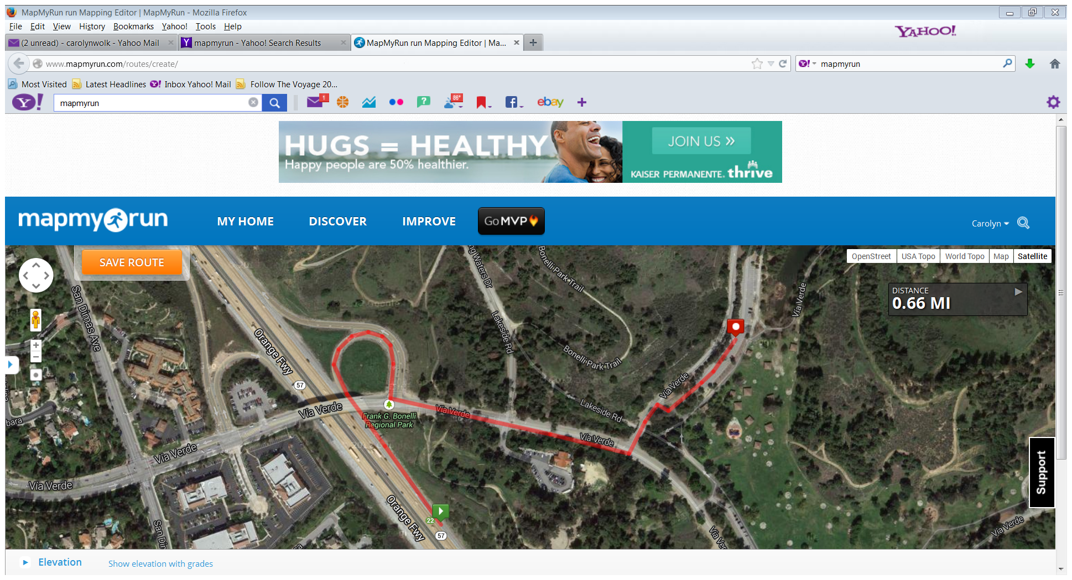**Directions to Bonelli Park South Shore**120 Via Verde, San Dimas, Ca. 91773  
*Coming from South of the 10 Fwy  
*Travel North on the 57 Fwy. Exit Via Verde / Raging Waters.  
*Make a left (Traveling East Towards the park entrance)  
*Pass through the Gate Entrance then make a left onto Eucalyptus.  
*Registration table is on the Right on the grass down a slope

**EUCALIPTUS DRIVE**

TRAVEL EAST

**PARK ENTRANCE.  
DROP OFF OR ENTER. MENTION YOUR GROUP YOUR WITH the personnel**

**10 Fwy**

**COMING FROM SOUTH   
57 FWY**

**VOLUNTEERS GO TO REGISTRATION TABLE**